**TEAM DETAILS**

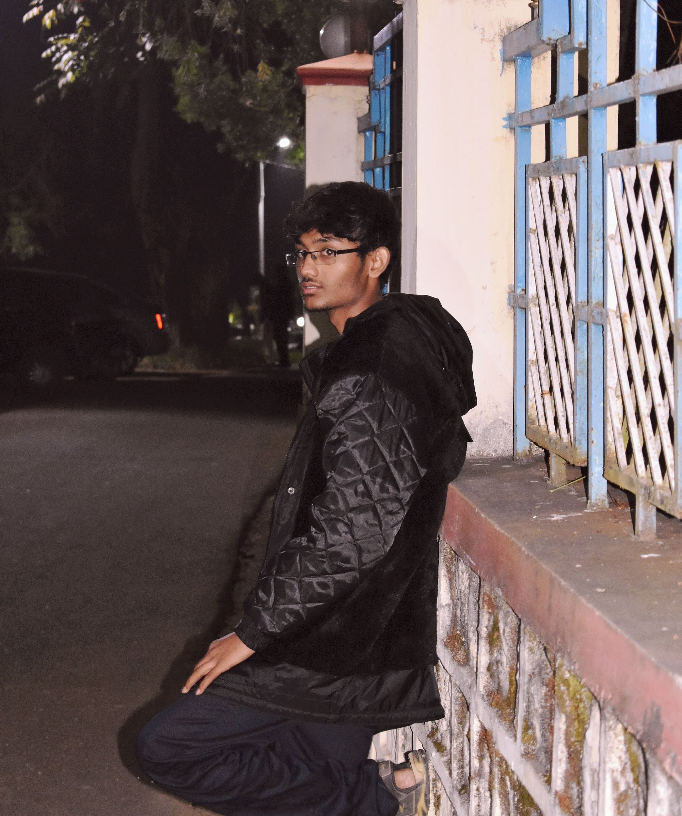

NAME:A.RAGAVENTHRAN

email:[1904205ece@cit.edu.in](mailto:1904205ece@cit.edu.in)

WORK:PART OF CREATING MODELS

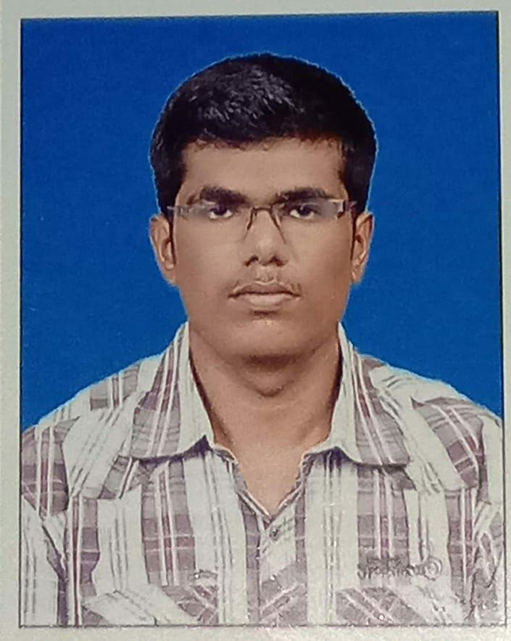

NAME:K.J.BHASKER

email:[1804012ece@cit.edu.in](mailto:1904205ece@cit.edu.in)

WORK:PART OF CREATING MODELS

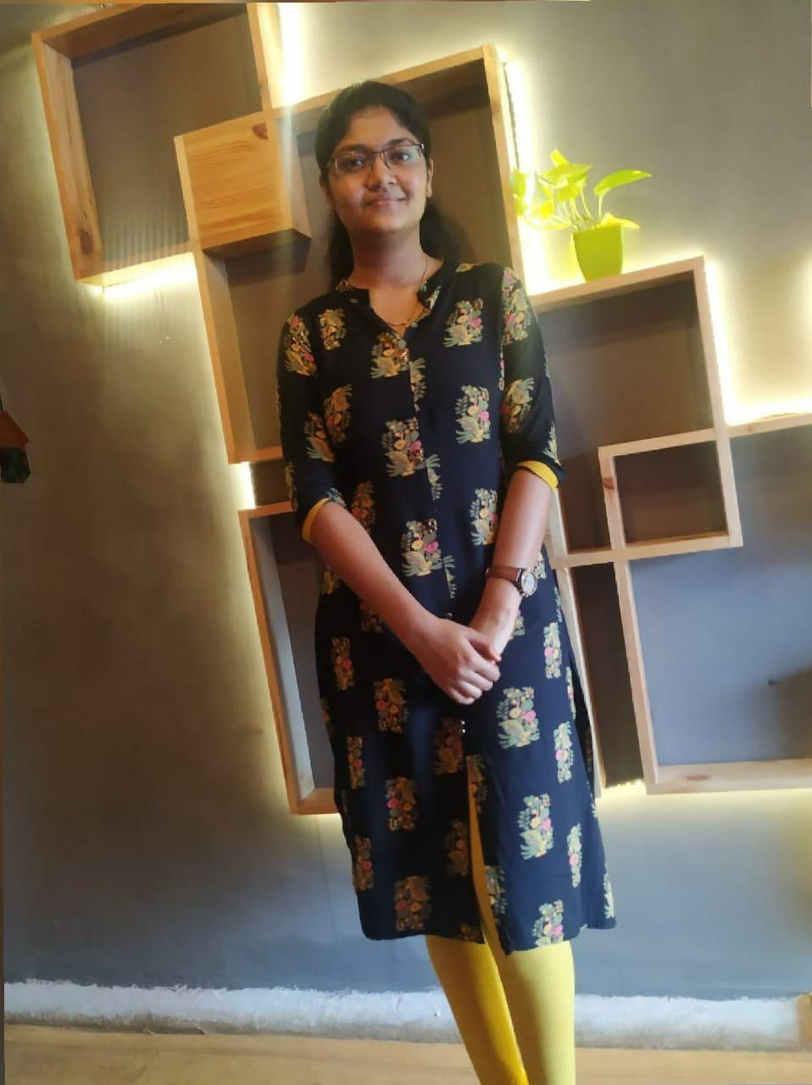

NAME:N.SUBIKSHA

email:[1804055ece@cit.edu.in](mailto:1904205ece@cit.edu.in)

WORK:DATASETS FETCHING AND DEBUGGING

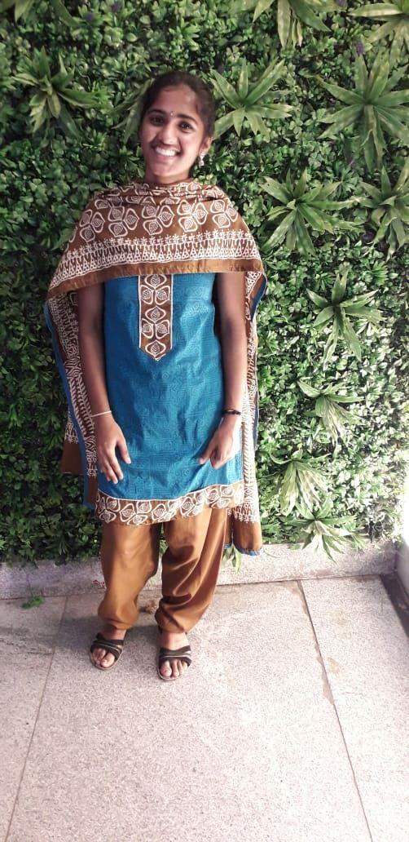

NAME:R.SIVASANDHIYA

email:[1804053ece@cit.edu.in](mailto:1904205ece@cit.edu.in)

WORK:PRESENTATIONS AND DEBUGGING